Session 2
- Install GCC on your computer and verify the installation by running gcc --version in your terminal or command prompt.
Answer:-
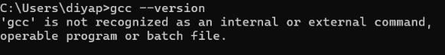

- Open VS Code or DevC++ and create a new file named hello.c. Write a C program that prints 'Hello, Instagram World!' to the console.
Answer:-
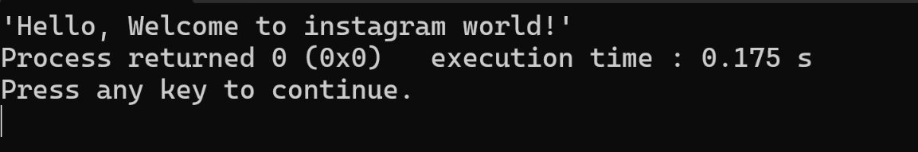

- Identify and label the header, main function, and return statement in your hello.c program using comments.
Answer:-
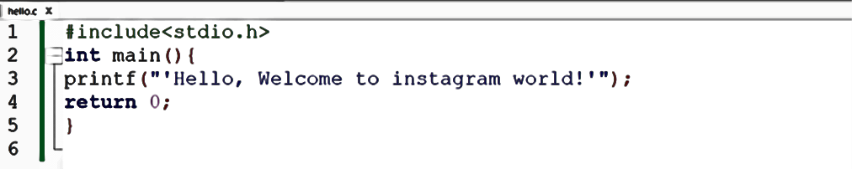
Here,
Header #include<stdio.h>
Main Function int main()
Return statement return 0;
- Compile your hello.c file using the GCC command line (gcc hello.c -o hello) and run the output file to display the message in your terminal On Windows, the output file will be hello.exe; on Linux/Mac, it will be hello.
Answer:-
